* ***NAME OF THE PROJECT* :** NUMBER GUESSING GAME IN MATLAB
* ***NAME OF THE STUDENT* ;** SRIJAN ROY
* ***DEPARTMENT ;*** COMPUTER SCIENCE ENGINEERING,IEM
* ***SECTION ;*** C
* ***CLASS ROLL NO ;*** 176
* ***ENROLLMENT NO ;*** 12022002002234
* ***SUBJECT ;*** IT WORKSHOP LAB
* ***SUBJECT CODE ;*** PCCCS392

**INTRODUCTION**

The guess the Number project in MATLAB based application that allows user to play a number guessing game against the system . the game is simple ; the system generates a random number between 1 and 100 and the user tries to guess the number . if the user guesses correctly they win a point . if the user guesses incorrectly the system wins a point. the game ends when the user reaches its maximum limits to guess the game when is being set in the game

The project has the following features ;

1. Professional looking GUI : the GUI is designed to be user friendly and visually appealing
2. User can choose how many rounds he or she wants to play . the user can choose single or multiple rounds
3. User can quit the game anytime: User can quit the game anytime and the game will save the current score

The project can be used for variety of purposes :

* Educational purposes: the game be used to teach students about probability and statistics
* Recreational purposes: the game can be used as a fun and challenging way to pass the time
* Competitive purposes: the game can be used as a competitive activity between friends or family members

**ALGORITHM** OR **PSEUDOCODE OF THE GAME :**

**trueNumber = randi(100);**

**userPrompt = 'Guess the number between 1 and 100 : ';**

**maxGuesses = 7;**

**numGuesses = 0;**

**usersGuess = input(userPrompt);**

**while numGuesses < maxGuesses**

**if (usersGuess > trueNumber)**

**fprintf(' Your guess of %d is too high.\n', usersGuess);**

**elseif (usersGuess < trueNumber)**

**fprintf(' Your guess of %d is too low.\n', usersGuess);**

**elseif usersGuess < 0**

**break; % Quit if they enter a negative number or try more than 6 times.**

**else**

**fprintf(' Your guess is %d is correct.\n', usersGuess);**

**break;**

**end**

**numGuesses = numGuesses + 1;**

**% Let them try again**

**userPrompt = sprintf('Attempt #%d. Guess the number between 1 and 100 : ', numGuesses);**

**usersGuess = input(userPrompt);**

**End**

**RESULTS:**

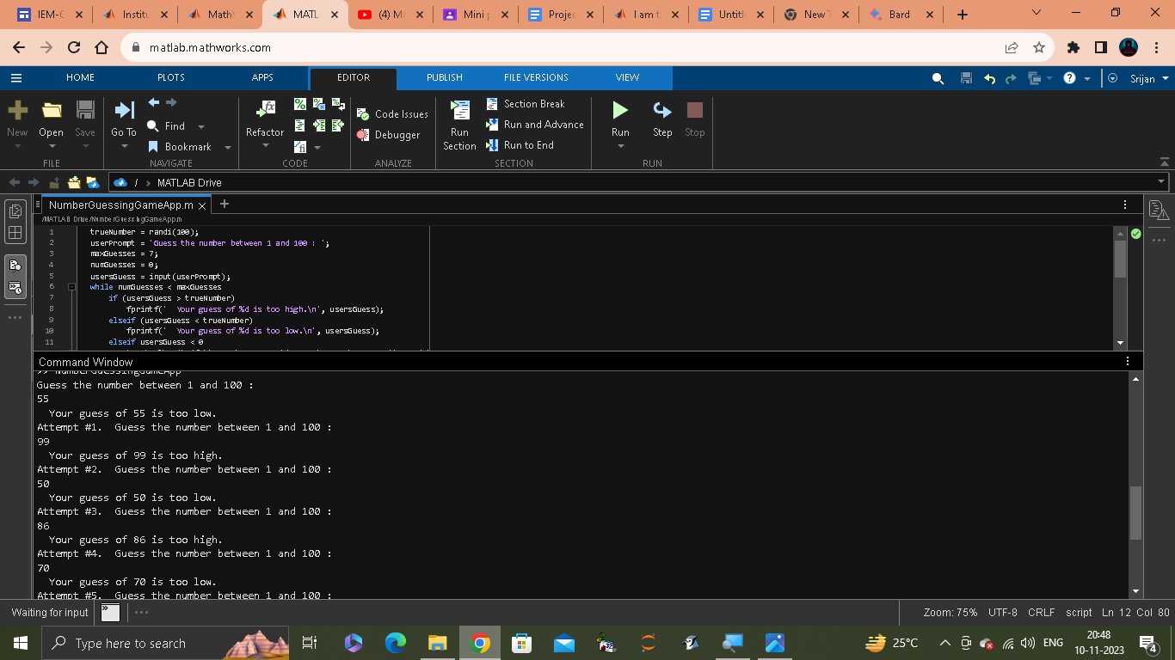

**CONCLUSION:**

**The Guess the Number project is a successful implementation of a number guessing game in MATLAB. The project has all of the required features, including a professional-looking GUI, the ability to choose the number of rounds to play, the ability to quit the game anytime, and the ability to keep track of the score for the user and the system. The game also includes a feature to declare the winner at the end of the game based on the highest score.**

**The project can be used for a variety of purposes, such as educational, recreational, and competitive purposes. It is also a good example of how MATLAB can be used to develop interactive and engaging applications.**

**Here are some specific conclusions about the project:**

* **The GUI is well-designed and easy to use. The game logic is sound and the game is fair.**
* **The game is fun and challenging.**
* **The project is well-documented and easy to understand.**

***Overall, the Guess the Number project is a well-executed project that demonstrates the developer's skills in MATLAB and GUI design..***